**ChatGPT - Who thy Boss?**

**NOTE: No Ctrl + Shift + I (Cheating Methods)**

**QUERY 1**

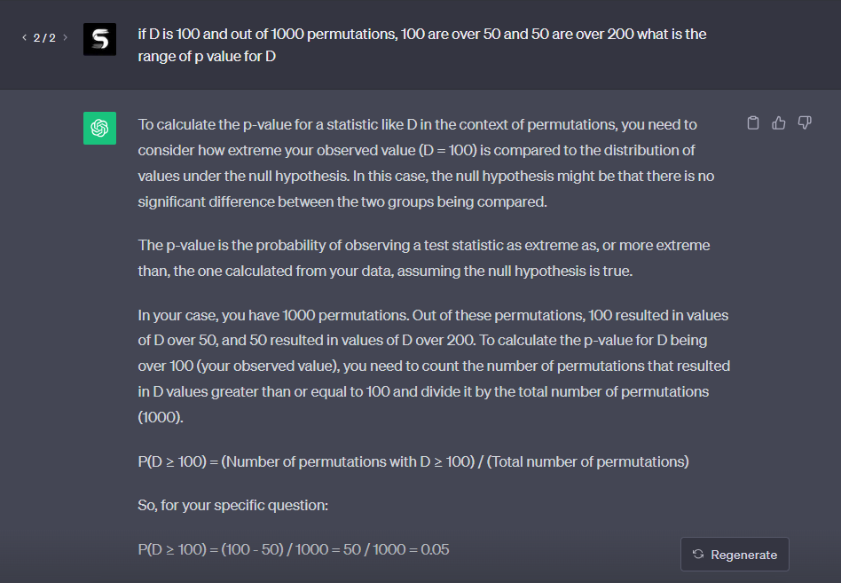

**Q: ChatGPT was unable to answer my question of “If D value is 100 and we run 1000 permutations of which 100 are over 50 and 50 are over 200.**

**A: ChatGPT answered with the answer of Lowerbound but did not answer the upper bound which was D <= 100/1000 or D<= 0.1. We also asked for a range but we got a specific question of D instead of a range (0.1, 0.05)**

**QUERY 2**

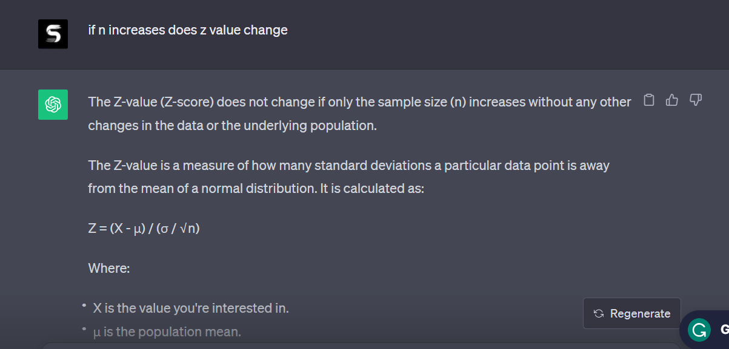

**Q: ChatGPT was unable to answer my question of whether changing the sample size changed the z-value in any form.**

**A: ChatGPT answered that changing the value of ‘n’ does not change the z-value even though it is clearly written in the formula. Apparently by Topper the cited site, suggests that changing the ‘n’ value changes the z-value ever so slightly and much more the more the sampling size is selected.**

**QUERY 3**

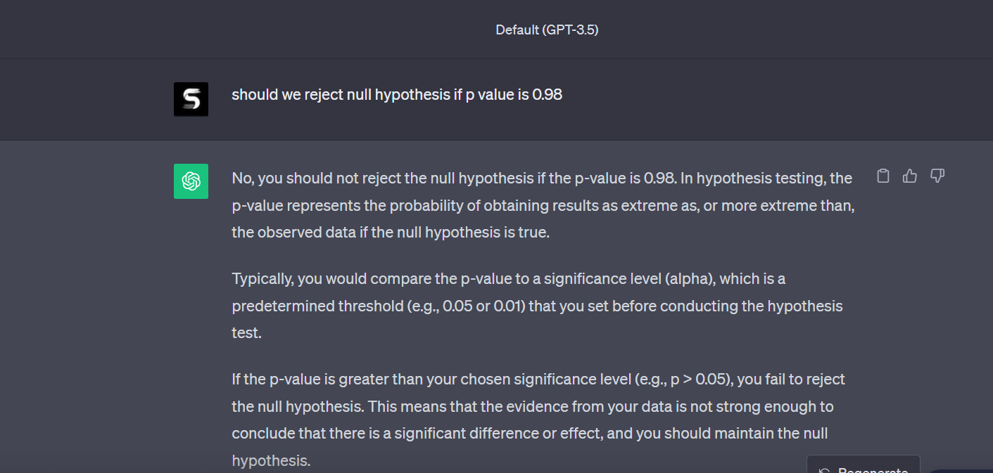

**Q: ChatGPT was unable to answer my question of whether we should reject the null hypothesis if the p-value is 0.98**

**A: ChatGPT answered that since the p-value is greater than 0.05 (the critical value) we cannot reject the null hypothesis. However, according to the bell curve, 0.98 as the p-value is equal to 0.02 p-value when the parameters are reversed. This yields in the system rejecting the null hypothesis. Hence, the current answer is that we reject the null hypothesis.**